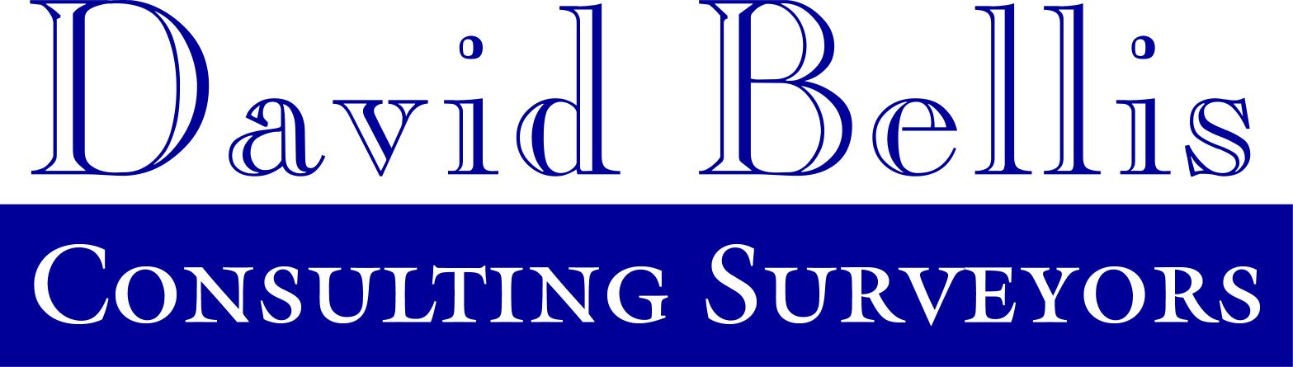
David Bellis Consulting Surveyors Ltd.
8, Mornington Terrace
Harrogate
North Yorkshire
HG1 5DH

Telephone 01423 529911
Fax 01423 529922

By

Coal Mining Report Order Form
(Please carry out a coal mining search in respect of the under mentioned address)
By placing an order with CoalSearch Plus+ you are agreeing to our standard terms and conditions, copies of which are available on request and can be downloaded from www.coalsearchplus.com

Property Details (Please use block capitals)

Address

Postcode

Grid reference or map reference if known
Is a plan enclosed? Yes No

Additional comment

Other details

Residential property (normal price £22.61 plus vat)? Commercial property (normal price £50.00 plus vat) ?

Please contact CoalSearchPlus+ for a quotation if the property is larger than 25 hectares

If you expect to order over 25 coal searches per month you may be eligible for a monthly account. Larger users may also be eligible for a volume related discount. If you wish to be contacted about an account or discount please indicate. Account Discount

Is the property intended for development ? Yes No
Is the search urgent (required in less than 3 working days)? Yes No

Delivery Options

Email (PDF format, no hard copy provided unless requested) Fax Post Fax and post

Ordering Organisation Details

Company
Address

Postcode
DX address
Telephone
Fax
Contact Email
Contact Name
Your Reference
Date

Payment Options

Cheque enclosed If ‘no’ CoalSearchPlus+ staff will contact you to discuss alternative payment options

David Bellis Consulting Surveyors Ltd. - Registered in England no. 5034580
Registered Address : Twelve Quays House, Egerton Wharf, Wirral, CH41 1LD

